Project Proposal Documentation

3. Medical Assistant
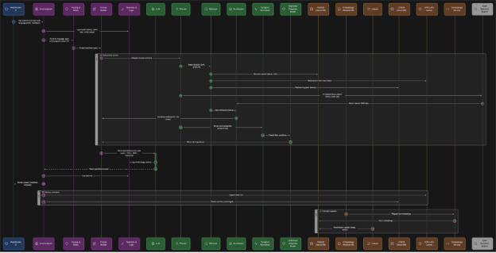

3.0 Model Summary
Multimodal Architecture: Orchestrator (FastAPI + MCP):
- LLM agent 1 (MedGemma): foundation model that wrap-up contextual understanding, determine action
- Diagnosis agent (LangChain + FAISS + Gemini): retrieve relevant diagnosis from given symptoms listing with semantic search, append relevant info to context on LLM agent 1.
- Agentic RAG (FAISS + SLM + MongoDB): retrieve relevant information to backup context or real-time update on data ingestion, append relevant info to context on LLM agent 2.
- Chat history agent (FAISS + SLM + MongoDB + LRU cache): retrieve past QA dialogues, semantic search to append relevant info to context on LLM agent 2.
- LLM agent 2 (MedGemma): medical model that give direct diagnosis + treatment (plan / medication) for the enduser to the UI
UI:
- Any template / React
- Connect to our Orchestrator + MongoDB
- Differ user session on their ID
- Load Balancer to Backend (optional)

3.1 Proposal Overview
Develop a multilingual medical AI assistant capable of Q&A, diagnosis support, and EMR-based reasoning.

3.2 Base LLM Options
Primary:
- Google/MedGemma-27B-it (medical-specialised)
Fallbacks:
- Deepseek-Qwen-8B
- Qwen3-8B
- Nvidia API-hosted medical models
- Gemini API medical mode

3.3 Data Pipeline
- Source: U.S. healthcare datasets (EHR/EMR, de-identified).
- Augmentation: Synthetic data generation, paraphrasing.
- Distillation: Reduce from larger models for efficiency.
- Backup: Maintain base dataset for RAG retrieval.

3.4 RAG Implementation
- English-only mode: all-MiniLM-L6-v2
- FAISS.
- Advanced multilingual mode: jinaai/jina-embeddings-v4 for charts, graphs, and multiple languages.
- LangChain pipeline: Optional for modular orchestration.

3.5 Expansion Features
- EMR Integration
  - Securely retrieve patient history for personalised diagnosis.
  - Cross-check medication conflicts.
- Symptom-to-Diagnosis Agent
  - NLP to extract symptom keywords.
  - RAG over diagnosis datasets to propose likely conditions.

3.6 VectorDB Options
- MongoDB Atlas
- Qdrant / ChromaDB

